***Florida International University***

***School of Computing and Information Sciences***

Software Engineering Focus

Feature Document

User Story #872

**Team Member:**

Pedro Carrillo

**Product Owner(s)​**:

Gummi Traustason

**Mentor(s)​**:

Masoud Sadjadi

**USER STORY​** - **“Start a game”**

* As a PLAYER I would like to start a game from my android phone to start practicing my skills on SkillCourt

Acceptance Criteria

* Game configurations should be possible (time, game mode, number of pads)
* A timer with the time left displayed should be send after i start a game until the game ends
* I can see my current score during the game

**Use Case Diagram**

Use case for start a game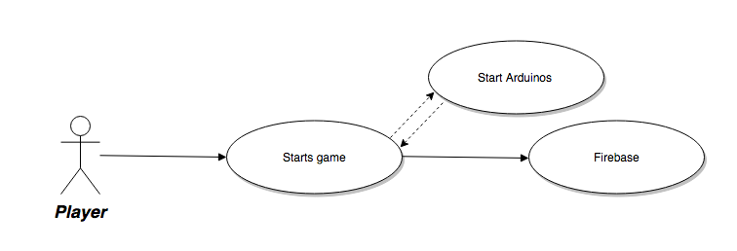

**Sequence Diagram**



**Class Diagram**

Untitled Diagram.png

**Unit and Integration Testing**

Test Case 1

○ **Purpose:** Test that I can’t go into Start Game or Create game screen without arduinos connection

○ **Precondition:** User is logged in. No arduino is on.

○ **Expected Result:** The screen should popup a window that says “No connection available”

○ **Actual Result:** Same as expected.

○ **Status: PASS**

Test Case 2

○ **Purpose:** Test the hit mode

○ **Precondition:** User is already logged in and there is arduinos connected

○ **Expected Result:** Player can play a game by touching the pressure sensors

○ **Actual Result:** Same as expected. But the sensors are not consistent.

○ **Status: PASS**

**Visual Diagram**

14859491_10209839349154714_1914548010_o.png14859491_10209839349154714_1914548010_o.png